
WEEK-10
AIM: Write unit tests for UI components.

DESCRIPTION: Unit testing UI components in Flutter involves verifying that individual widgets behave as expected in isolation, without running the full application. This is typically done using the flutter_test package, which provides tools like testWidgets and WidgetTester to build widgets in a test environment, simulate user interactions, and check their rendered output. Developers write tests to ensure that widgets display the correct content, respond to input events, and handle different states such as loading, error, or empty data. By asserting the presence of specific text, buttons, or other UI elements, unit tests help catch errors early, maintain UI consistency, and improve the reliability of the application during development. Overall, unit testing UI components ensures that each widget performs its intended function and provides a stable, predictable user experience.

PROGRAM 1:-

(Main.dart)
import 'package:flutter/material.dart';
void main() => runApp(MaterialApp(home: GreetingWidget(name: 'Alice'))); class GreetingWidget extends StatelessWidget {
final String name;
const GreetingWidget({Key? key, required this.name}) : super(key: key); @override
Widget build(BuildContext context) { return Scaffold(
appBar: AppBar(title: const Text('Greeting Test Example')), body: Center(
child: Text( 'Hello, $name!',
style: const TextStyle(fontSize: 24),
),
),
);
}
}

PROGRAM 2:-
(Widget_test.dart)
import 'package:flutter_test/flutter_test.dart'; import 'package:flutter/material.dart';
import 'package:flutter_application_1/main.dart';

void main() {
testWidgets('GreetingWidget shows correct text', (WidgetTester tester) async {
// Build our widget and trigger a frame
await tester.pumpWidget(const MaterialApp( home: GreetingWidget(name: 'Alice'),
));

// Verify that the text is displayed correctly expect(find.text('Hello, Alice!'), findsOneWidget); expect(find.text('Hello, John!'), findsNothing);
});
}

OUTPUT:
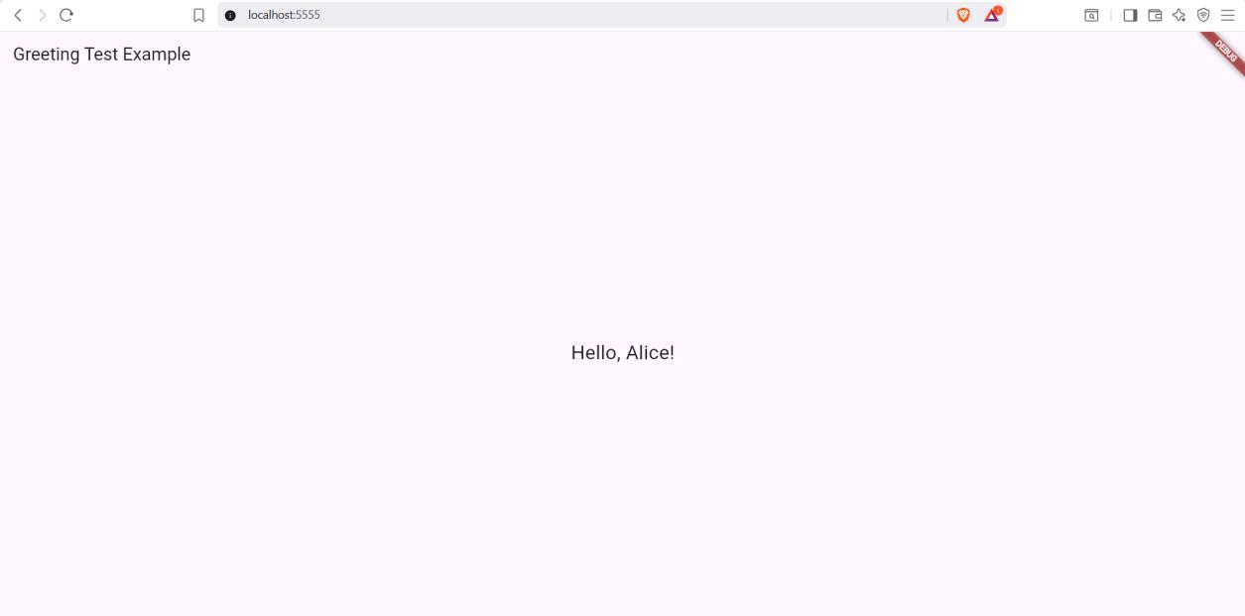

PS D:\5th sem\Flutter\flutter_application_1> flutter test 00:02 +1: All tests passed!

B) AIM: Use Flutter's debugging tools to identify and fix issues.

DESCRIPTION: Flutter’s debugging tools help developers quickly identify and fix issues in their apps. Using debugPrint() and assertions, developers can track state changes and catch errors during development. The Flutter DevTools, especially the Flutter Inspector, allow inspection of the widget tree, layout, and rebuild counts, while the Debug Console displays logs and exceptions. These tools provide real-time insights, making it easier to understand app behavior and resolve problems efficiently.

PROGRAM:
import 'package:flutter/material.dart'; void main() {
// Enable debugging print statements debugPrint('App starting...'); runApp(MaterialApp(home: DebugDemo()));
}
class DebugDemo extends StatefulWidget { @override
_DebugDemoState createState() => _DebugDemoState();
}
class _DebugDemoState extends State<DebugDemo> { int counter = 0;
void _incrementCounter() { setState(() {
counter++;
// Debug print for tracking value changes debugPrint('Counter updated to: $counter');

// Example assertion: Counter should never exceed 5 assert(counter <= 5, 'Counter value exceeded 5!');
});
}
@override
Widget build(BuildContext context) {
// Print widget rebuilds in console for debugging debugPrint('Widget rebuilt with counter = $counter'); return Scaffold(
appBar: AppBar(title: const Text('Debugging Demo')), body: Center(
child: Column(
mainAxisAlignment: MainAxisAlignment.center, children: [

Text(
'Counter Value: $counter',
style: const TextStyle(fontSize: 24),
),
const SizedBox(height: 20), ElevatedButton(
onPressed: _incrementCounter,
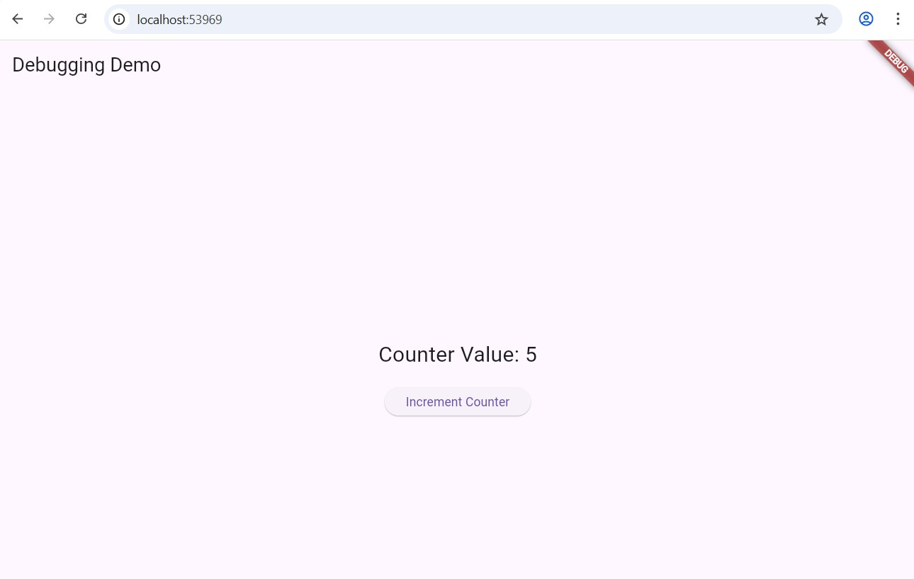
child: const Text('Increment Counter'),
),
],
),
),
);
}
}

OUTPUT:

PS D:\5th sem\Flutter\flutter_application_1> flutter run

A Dart VM Service on Chrome is available at: http://127.0.0.1:64735/F-MO2mqjs00= App starting...
Widget rebuilt with counter = 0
The Flutter DevTools debugger and profiler on Chrome is available at: http://127.0.0.1:9101?uri=http://127.0.0.1:64735/F-MO2mqjs00= Counter updated to: 1
Widget rebuilt with counter = 1 Counter updated to: 2
Widget rebuilt with counter = 2 Counter updated to: 3
Widget rebuilt with counter = 3 Counter updated to: 4
Widget rebuilt with counter = 4 Counter updated to: 5
Widget rebuilt with counter = 5

Counter updated to: 6
══╡ EXCEPTION CAUGHT BY GESTURE
╞════════════════════════════════════════════════════
═══════════════
The following assertion was thrown while handling a gesture:
Assertion failed: file:///D:/5th%20sem/Flutter/flutter_application_1/lib/main.dart:20:14 counter <= 5
"Counter value exceeded 5!"

